**EasyCollect APIs (READ ME) –**

Link to global documentation : [SPS & SPS-Signature Documentation (worldline-solutions.com)](https://ssl-sps-sign-service.vm-rct.worldline-solutions.com/documentation/)

**WHERE TO START ? WHAT IS THE IMPLEMENTATION LOGIC OF THE EASYCOLLECT SDD APIs ?**

The direct debit logic takes place in two steps :

**Step 1 : Creation and signature of electronic mandates :**

* Call the API ‘InitSession’ (through the CreditorId parameter in particular)
  + - to create a mandate with status « create ».
    - to get a Signature link URL

Example of API REST iniSession call :

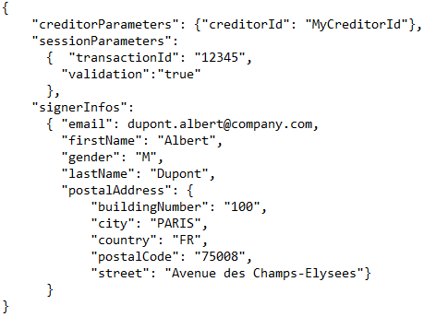

* The UMR reference is generated when the debtor signs its mandate. A POST request is sent to the URL indicated in the URL_OK parameter, as the following example :

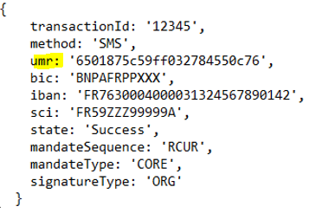

* See the online documentation related to the Signature :

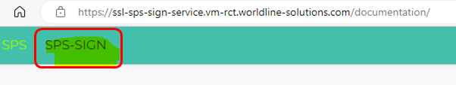

**Step 2 : Creation and management of SDDs :**

* Call the API ‘CreateSdd’ by parameterizing the UMR generated in step 1.
* A range of Creditor APIs is available to manage SDD direct debits
* See the online documentation related to mandates and SDD management :

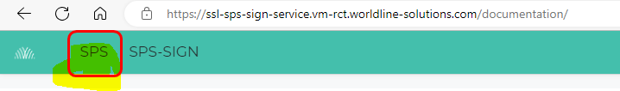

**CERTIFICATE**

* In the test environment, calls to the e-signature InitSession API must be signed with the security certificate provided below. The procedure for authentication via SOAP UI is explained in the documentation (EasyCollect e-Signature WebService Integration Guide).

* In a production environment, for security reasons, the EASYCOLLECT production application will not allow self-signed certificates. Therefore, please provide an X509/p12 Signature certificate issued by a certificate authority (Entrust, etc.), simple classic standard SSL type certificate within the meaning of eIDAS standard (no need to subscribe to a certificate for PSD2 – neither QSealC nor QWAC-).

Please note that :

* The call to the Signature API 'InitSession' (SPS-Sign) is signed by certificate
* Calls to creditor APIs (SPS APIs) are signed by login/password (sent by email)

**API CALLS / END POINTS - URL**

Here after are the different URLs for calling the APIs ('EndPoints') in **SOAP** protocol :

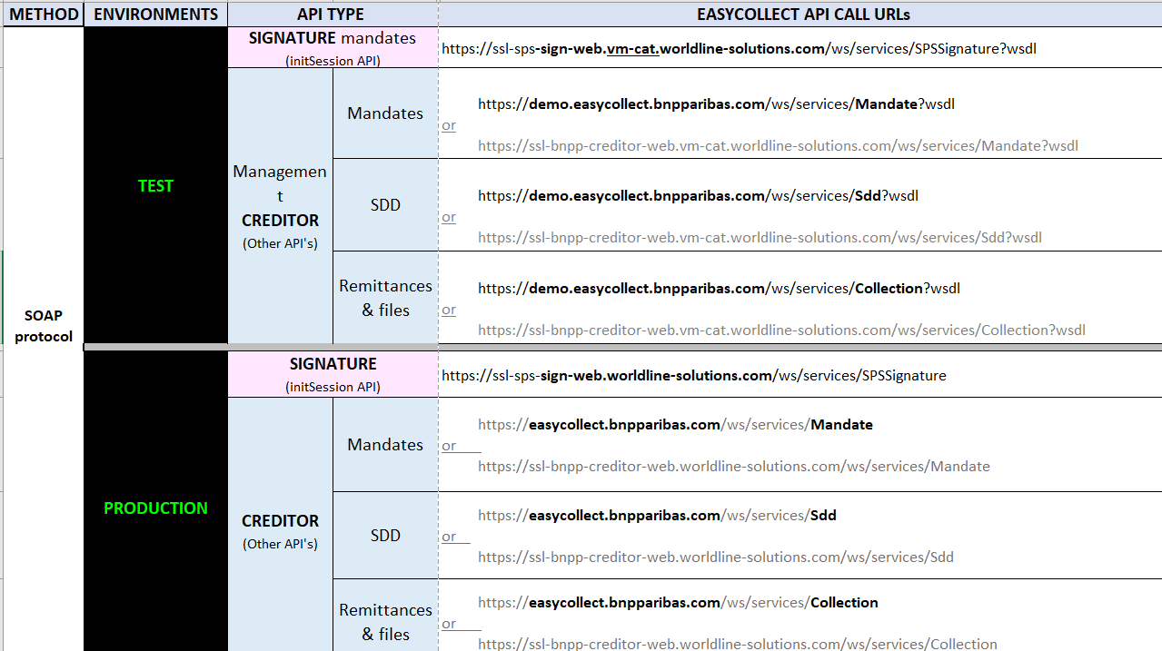

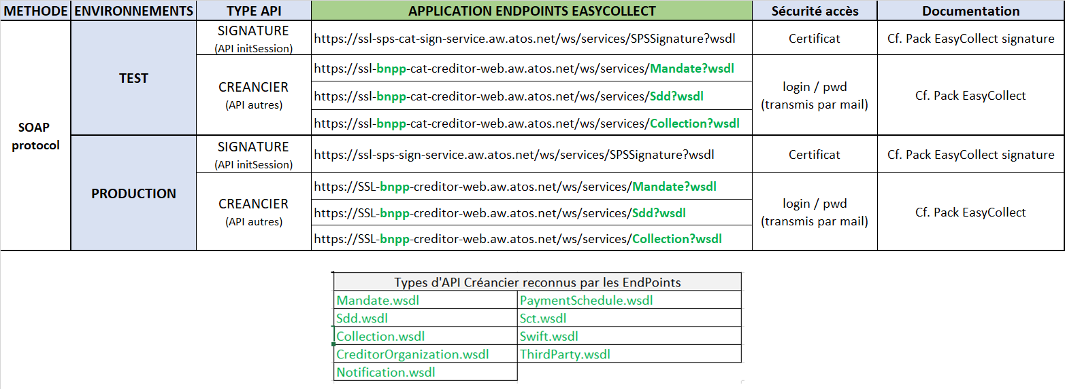

*On SoapUI, you must use the Creditor APIs with the "authenticate pre-emptively" option.*

*SOAP URL editable in EXCEL format 🡪*

**REST** API : The SIGNATURE API 'InitSession' can also be called in REST architecture. The response format returns content in JSON (indicated in the Content-Type header of the response) -> cf. file « REST api-docs.json » of the documentation.



Other mandate management APIs are also accessible in REST (such as GetAttachmentsDateForMandate). Here are the EndPoints in REST :

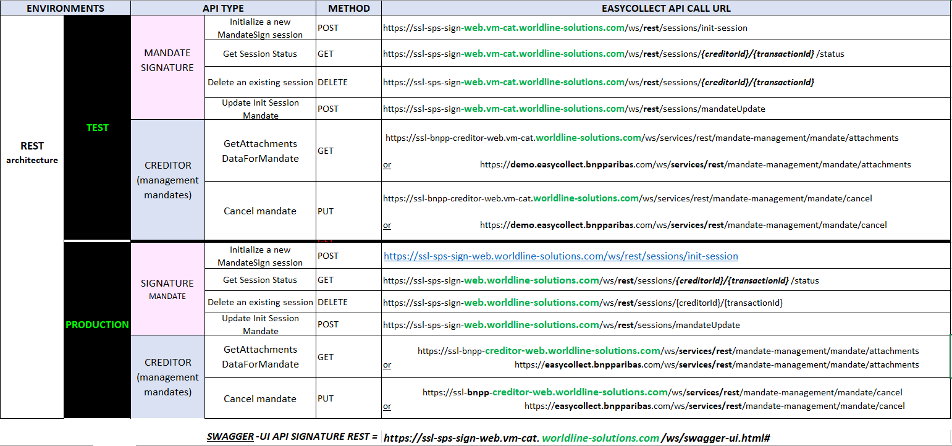

SWAGGER-UI API SIGNATURE REST = [https://ssl-sps-sign-web.vm-cat.worldline-solutions.com/ws/swagger-ui.html#](https://ssl-sps-sign-web.vm-cat.worldline-solutions.com/ws/swagger-ui.html)

*REST URL editable in EXCEL format 🡪 *

ERROR CODES : the description of the error codes is available in the :



* Link “SPS-Sign/Web Service Specifications/SOAP Web Service Description”
* or file “SPS-Sign/Web Service Specifications/REST Web Service Description”
* file “SPS/Web Service Specifications”

Please inform us when using the "CREANCIER" REST APIs because this requires a specific activation on the WORLDLINE configuration side.

**ELECTRONIC SIGNATURE OF A MANDATE**

To generate a "Signature" URL link to be submited to the debtor, the InitSession API is used. From the generated link, the debtor can proceed to the electronic signature of his mandate in three steps, as follows :

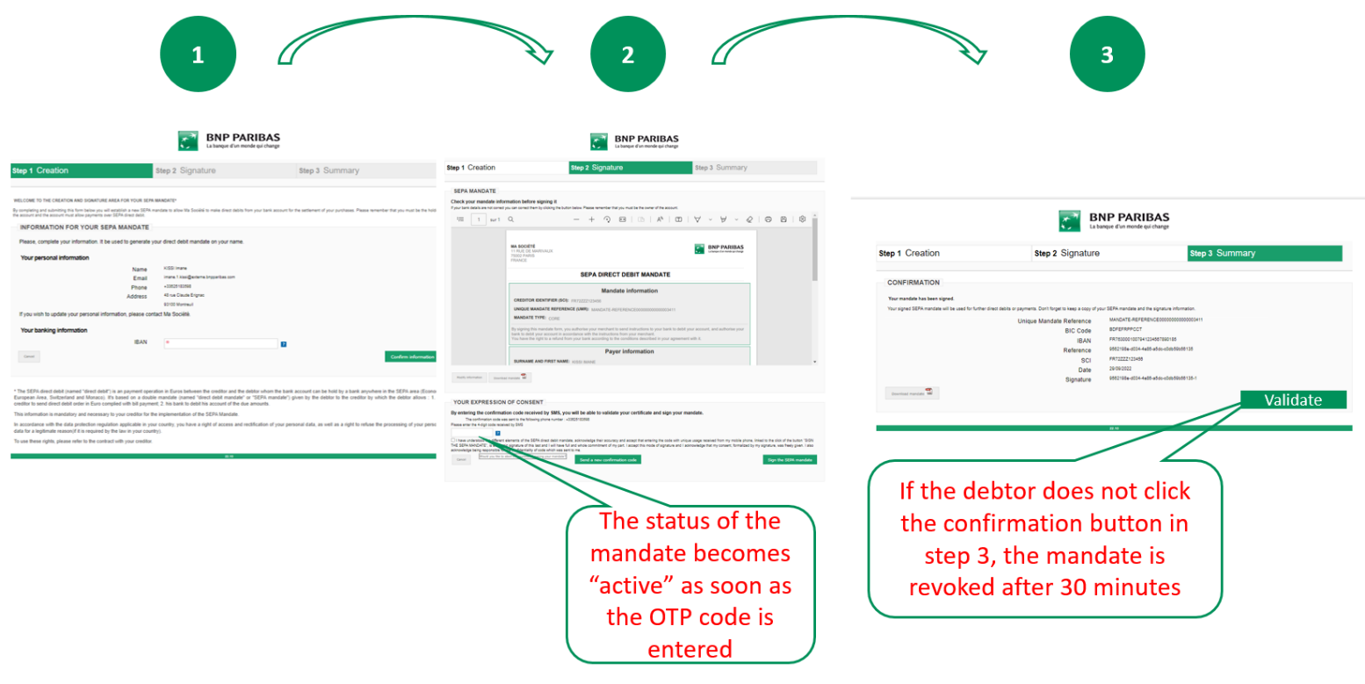

=> To avoid unpleasant surprises (revocation of the mandate if the debtor forgets to click on the button in step 3), we recommend to disable step 3 by activating the “SkipSumaryPage” parameter when calling the InitSession API.

Indeed, this makes it possible to skip step 3 by redirecting step 2 directly to the site (to "urlOK") without going through step 3. In this way, the mandates will not risk being revoked. To do so, simply activate the "skipSummaryPage" parameter by changing the value to true :

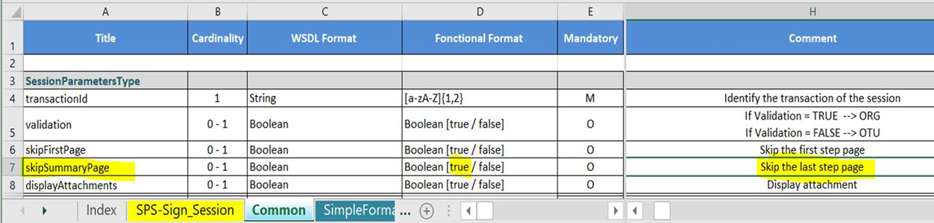

Link to documentation : [Common – SPS & SPS-Signature Documentation (worldline-solutions.com)](https://ssl-sps-sign-service.vm-rct.worldline-solutions.com/documentation/sps-sign/web-services-specifications/3.-soap-web-services-description/wsdl-description/3.-common/)

**HOW TO OBTAIN THE STATUS OF SIGNATURES AND MANDATES ?**

It is possible, via API, to obtain the status of a signature and also the status of a mandate.

             1/ Identify expired (unsigned) signature links using the **'getSessionStatus' API**

              2/ Identification of active mandates to retrieve the UMR using the **'getMandate' API**

Indeed, a difference must be made between the status types returned by the GetSessionStatus API and the GetMandate API : the first focuses on the status of the signature “session” while the second focuses on the status of the mandate :

1. The GetSessionStatus API returns the status of the session initiated by the InitSession API with two possible values: ACCEPT or REJECT :

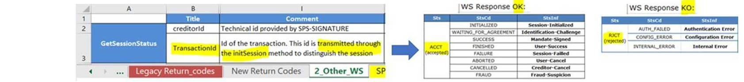

Link to documentation : [Other WS – SPS & SPS-Signature Documentation (worldline-solutions.com)](https://ssl-sps-sign-service.vm-rct.worldline-solutions.com/documentation/sps-sign/web-services-specifications/3.-soap-web-services-description/wsdl-description/7.-other-ws/)

1. The GetMandate API returns the status of the mandate: 'ACTIVE' or not (REVOKED, SUSPENDED, CANCELED...) :

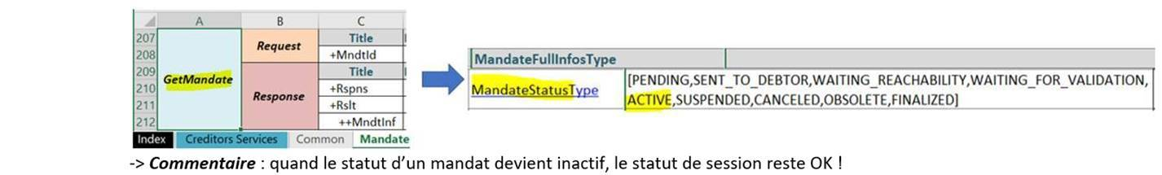

Note : when the status of a mandate becomes inactive, the session status remains Accepted

Link to documentation : [Mandate – SPS & SPS-Signature Documentation (worldline-solutions.com)](https://ssl-sps-sign-service.vm-rct.worldline-solutions.com/documentation/sps/web-services-description/2.-soap-web-services-description/wsdl-description/4.-mandate/)

**HOW DO I DISPLAY THE COMPANY NAME ON MANDATES IF I HAVE 'COMPANY' CLIENTS ?**

By default, the mandate is an "CONSUMER" format; however, it is possible to choose a "COMPANY" format by activating some SIGNATURE API parameters to display the company name and the trade name of the debtor company (in addition to the name of the signatory, which remains mandatory from a legal point of view) :

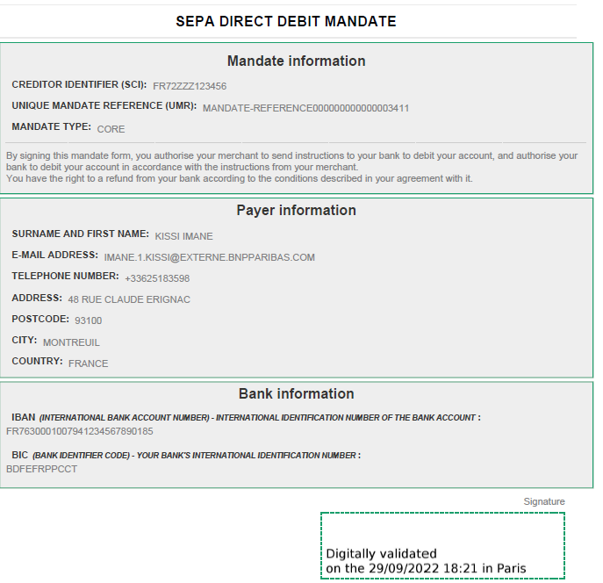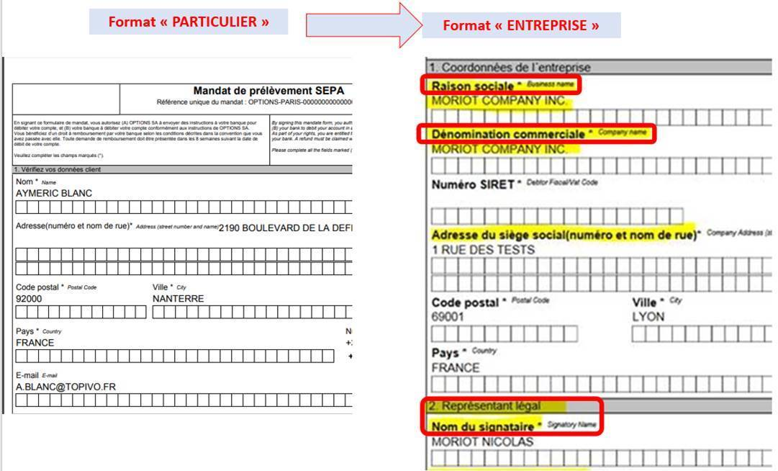

**« Company format »**

**« Consumer format »**

**Business** **name**

**Company** **name**

**Signatory name**

To choose the "Company" format of the mandates (to display the information of a legal entity on the mandates), the "CompanyInfos" parameter section allows you to fill in a debtor of "company" type by following these steps :

* Add the "corporateIndicator" parameter with the value "true"
* Add the "companyName" parameter indicating the company name
* Add the parameter « signerPositionOccupied » with a value (for example « collaborator », « purchasing manager », « director », etc.)

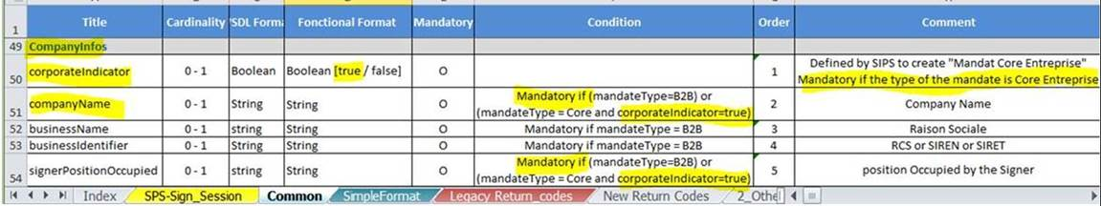

Link to documentation : [Common – SPS & SPS-Signature Documentation (worldline-solutions.com)](https://ssl-sps-sign-service.vm-rct.worldline-solutions.com/documentation/sps-sign/web-services-specifications/3.-soap-web-services-description/wsdl-description/3.-common/)

In addition, you can plan to search for mandates by "Company Name" (in addition to the name / surname of the signatory). Indeed, it is possible to search by company name by using the search criteria "Ultimate Debtor name" (accessible by activating the 'advanced search') :

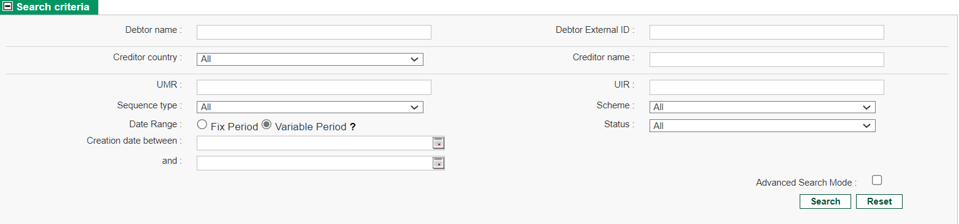

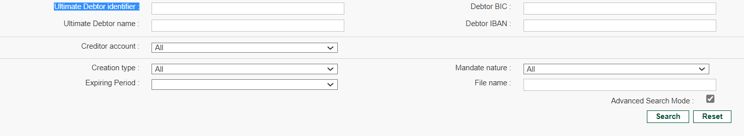

Of course, to use this search criterion, it is necessary to feed this information (company name or trade name) which corresponds to the field "ultimateDebtorName", as follows :

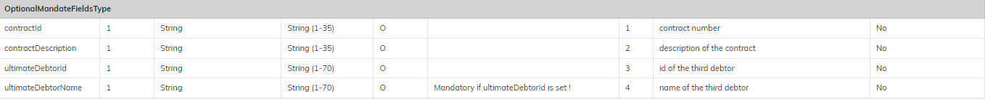

New mandate flow :

Valuation of the company name via the Signature mandate API

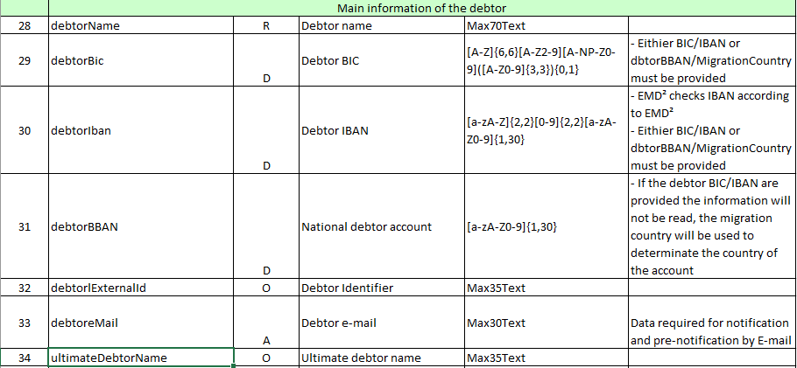

Existing stock mandates :

Enrichment of the company name via the import of mandate files (update)

**Search by company via the criterion "Ultimate Debtor name" :**

* In start mode :
* In contains mode :



XXXXX



%XXXXX%

Link to documentation : [Common – SPS & SPS-Signature Documentation (worldline-solutions.com)](https://ssl-sps-sign-service.vm-rct.worldline-solutions.com/documentation/sps-sign/web-services-specifications/3.-soap-web-services-description/wsdl-description/3.-common/)

**HOW TO AUTOMATE THE REMITTANCES IN BANK OF DIRECT DEBITS ?**

* EasyCollect generates a daily direct debit file that the creditor must send to his bank (XML format type PAIN008 standard 20022)
* To retrieve this file, this can be done in an automated way using API : the logic is to identify the available pain08 files (API SearchFileCollection) to download the right direct debit file (API GetFileCollection)

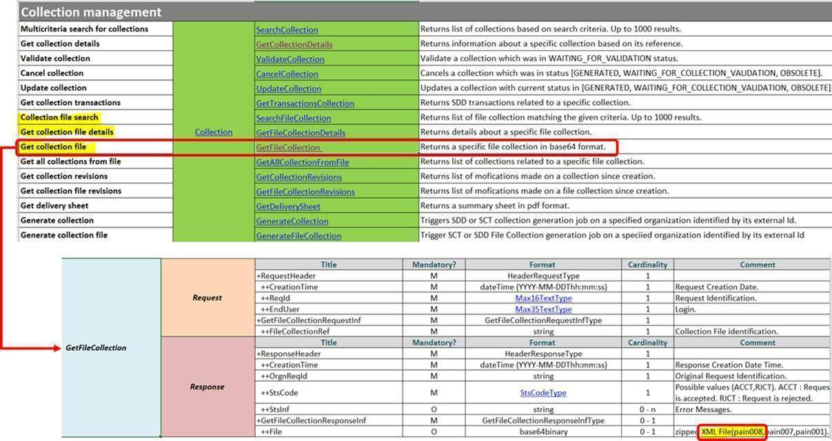

Link to documentation : [Collection – SPS & SPS-Signature Documentation (worldline-solutions.com)](https://ssl-sps-sign-service.vm-rct.worldline-solutions.com/documentation/sps/web-services-description/2.-soap-web-services-description/wsdl-description/7.-collection/)

• Bank remittance can be automated by retrieving and depositing this PAIN008 file in a bank communication tool (for example in an EBICS directory provided for this purpose).

**TEST DEBTOR ACCOUNT USABLE**

Since EASYCOLLECT checks the validity of account formats, it is necessary to use a valid debtor test account.

If necessary, here is an example of a valid debtor IBAN that can be used for your tests:

* **Iban valid debtor test = FR7617106000261813872100063**

**FOR MORE INFORMATION**

*Online documentation :* [*https://ssl-sps-sign-service.vm-rct.worldline-solutions.com/documentation/*](https://ssl-sps-sign-service.vm-rct.worldline-solutions.com/documentation/)

* ***SPS*** *(Sepa Payment Suite) section : API documentation related to creditor services*
* ***SPS-SIGN*** *(SPS SIGNature) section : API documentation to mandate signing services (initSession API)*